**Assessment – 1**

|  |  |
| --- | --- |
| **NAME** | MULLAPUDI SRI RAMYA |
| **ROLL NO** | 20T91A1223 |
| **COLLEGE NAME** | GIET ENGINEERING COLLEGE |
| **EMAIL** | 20t91a1223@gmail.com |

1. Write a Python program to calculate the area of a rectangle given its length and width

**Program:**

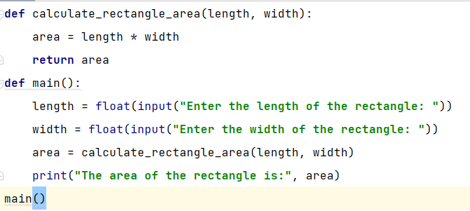

**Output:**

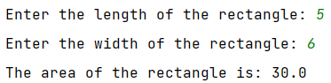

2. Write a program to convert miles to kilometres.

**Program:** 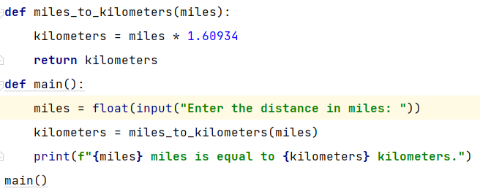

**Output:**

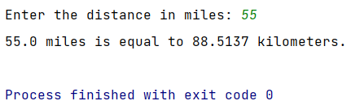

**3.** Write a function to check if a given string is a palindrome

**Program**:

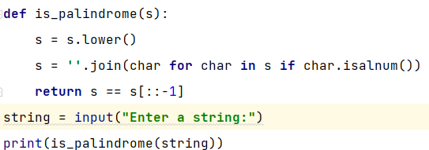

**Output:**

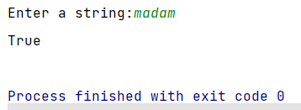

**4.** Write a Python program to find the second largest element in a list

**Program**:

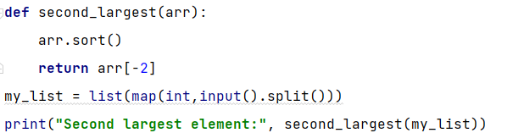

**Output:**

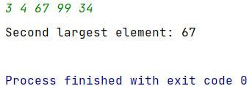

5.Explain what indentation means in Python

**Program**:

Indentation in Python refers to the use of spaces or tabs at the beginning of lines of code to visually structure and organize the program. It helps indicate which lines of code belong together in the same block or scope, such as within loops, conditional statements, or function definitions. In Python, indentation is not just for visual clarity; it is a fundamental aspect of the language's syntax and is used by the interpreter to understand the logical structure of the code.

**Example** **Code**:

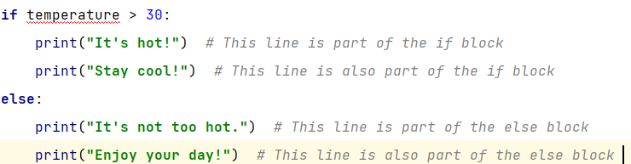

6. Write a program to perform set difference operation

**Program**:

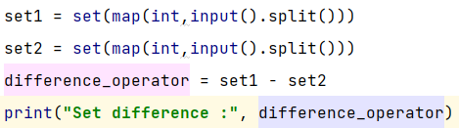

**Output**:

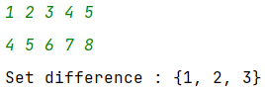

7. Write a Python program to print numbers from 1 to 10 using a while loop.

**Program**:

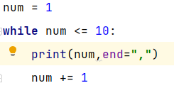

**Output**:



8. Write a program to calculate the factorial of a number using a while loop

**Program**:

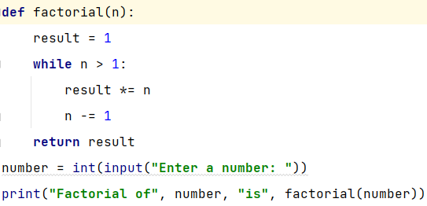

**Output**:



9. Write a Python program to check if a number is positive, negative, or zero using if-elif-else statements

**Program**:

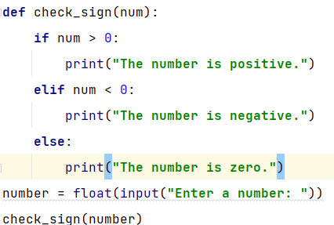

**Output**:

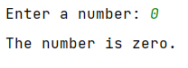

10. Write a program to determine the largest among three numbers using conditional statements.

**Program**:

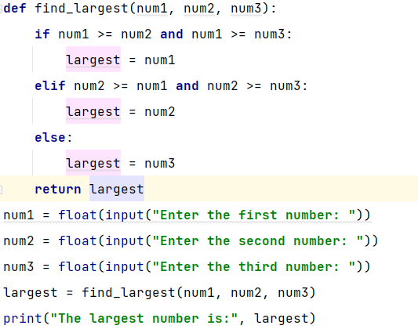

**Output**:

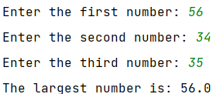

11. Write a Python program to create a numpy array filled with ones of given shape.

**Program**:

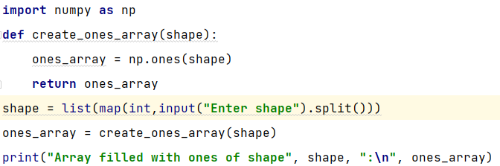

**Output**:

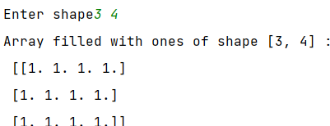

12. Write a program to create a 2D numpy array initialized with random integers.

**Program**:

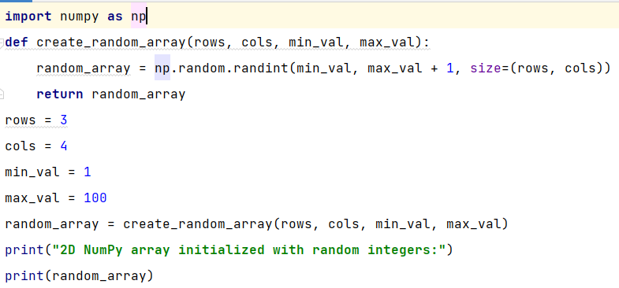

**Output**:

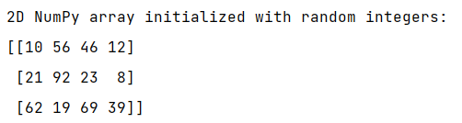

**13.** Write a Python program to generate an array of evenly spaced numbers over a specified range using linspace.

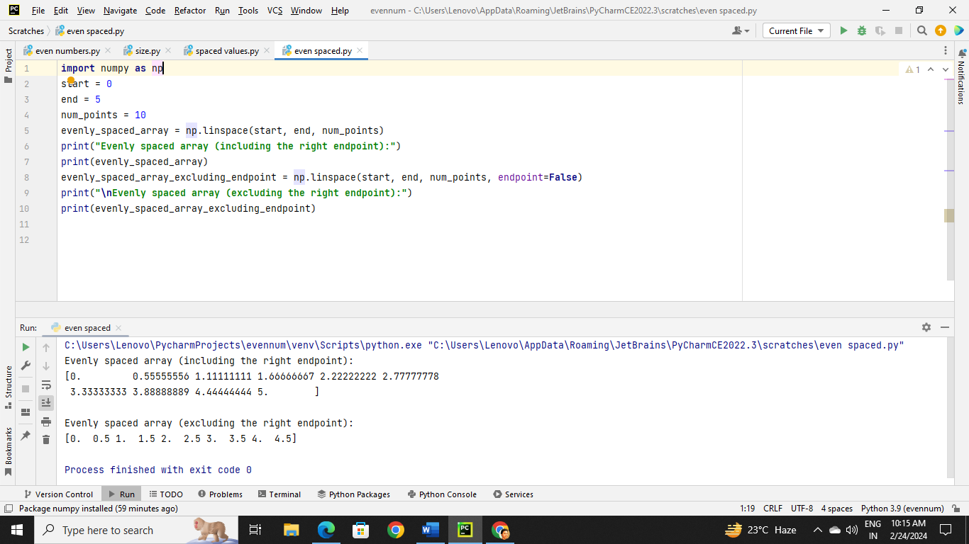**Program:**

14.Write a program to generate an array of 10 equally spaced values between 1 and 100 using line space.

**Program:**

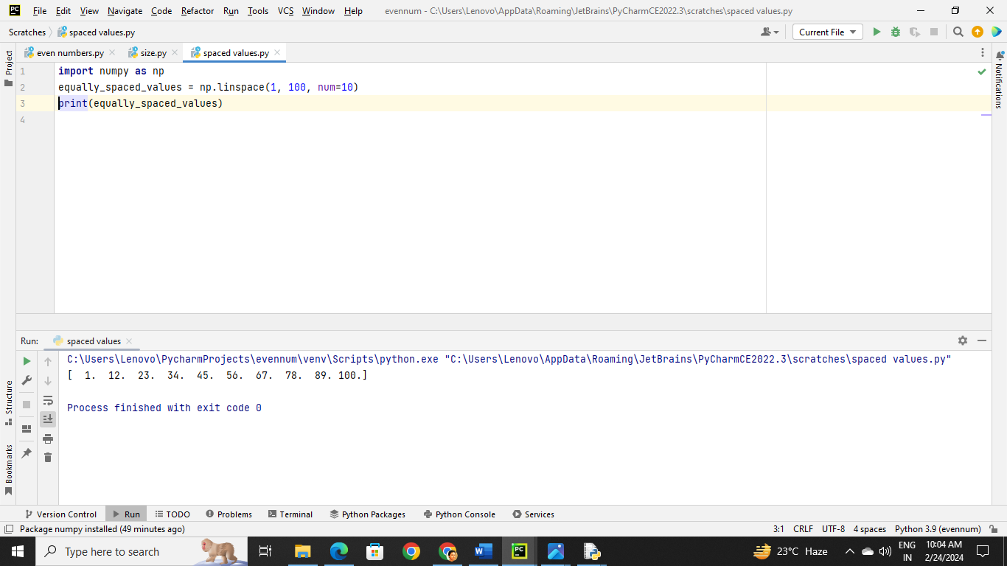

15. Write a Python program to create an array containing even numbers from 2 to 20 using arrange.

**Program:**

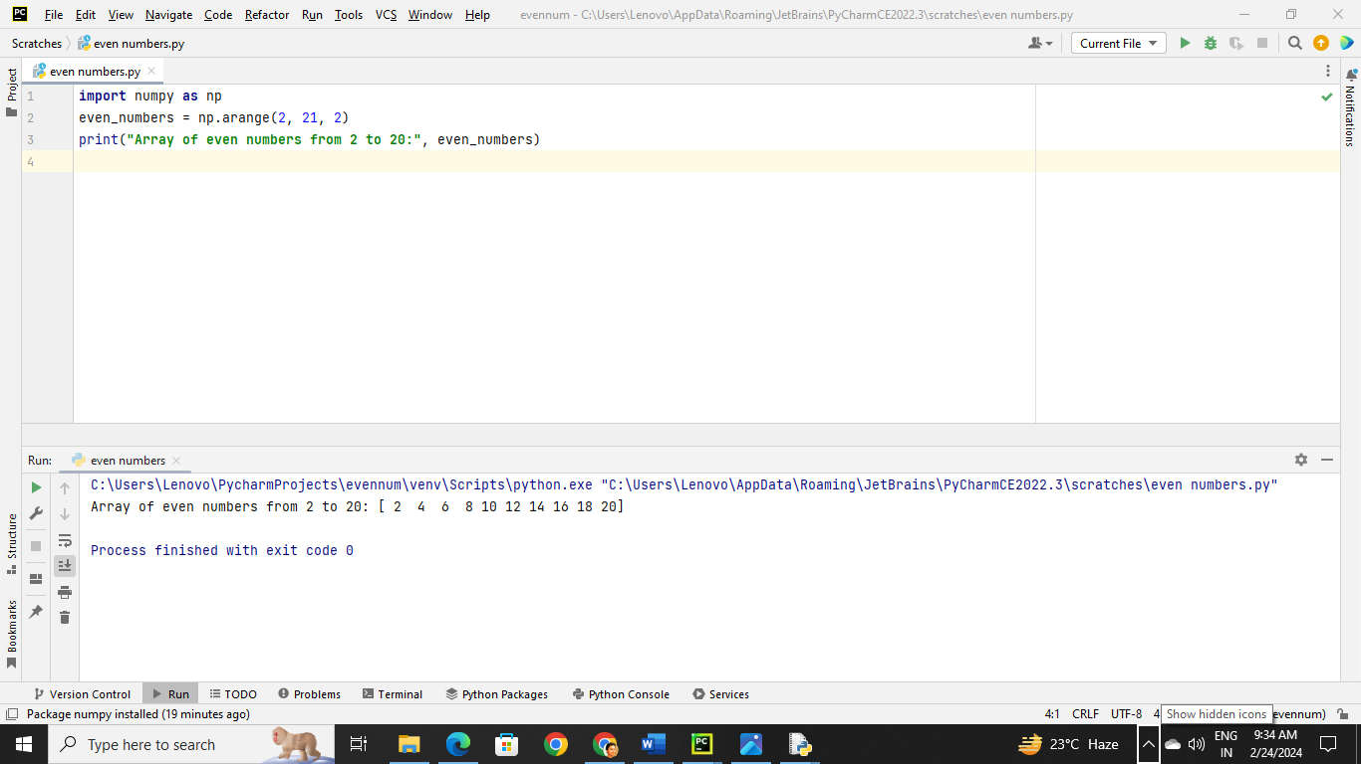**16.** Write a program to create an array containing numbers from 1 to 10 with a step size of 0.5 using arrange.

